Shop Bridge Application using API call

1. **Shopping bridge Database Creation**

Created the Database with the name shoppingBridge and created the table name ProductInventory and added the Inventory details. Please find the below screenshot. 15 minutes taken to complete the database creation and adding content

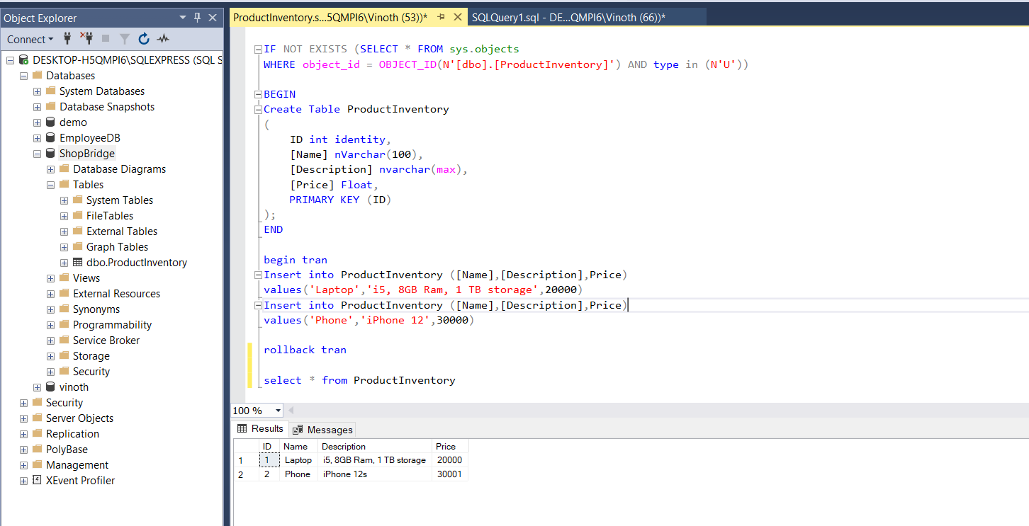

1. **My UI of Inventory list**

I designed the UI based on MVC and used HTTP WEBAPI Clients to call the services like (GET, POST, PUT, DELETE). Please find the screenshot of the UI.

**Home Page of ShopBridge Application**

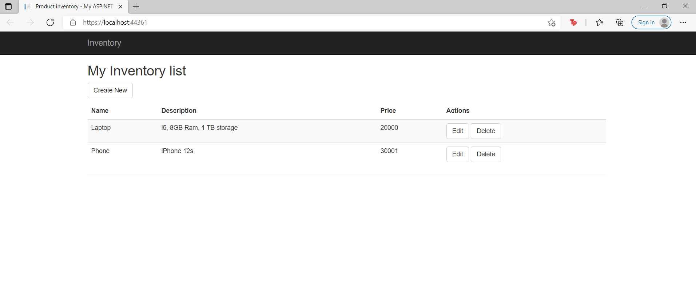

**Page to Create/Add new Inventory**

When I click Create new button it will redirect me to Add/Edit page to add the new inventory and to Edit/ Modify the existing product in my database.

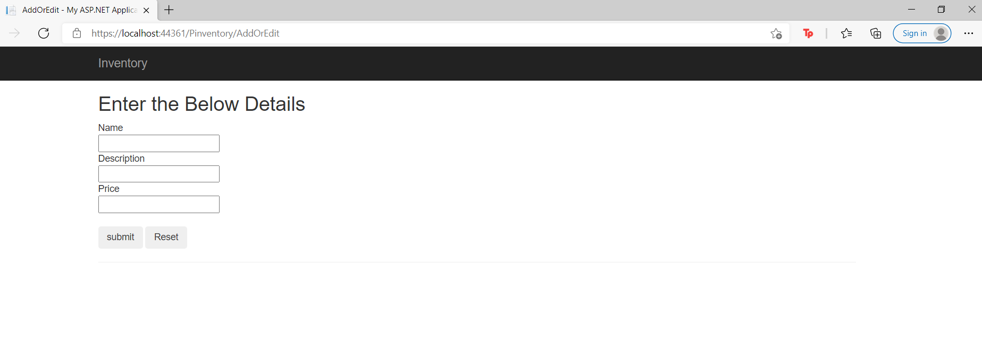

After entering the Name, Description, Price and clicking on submit will redirect to the home page and display the new item or Edited item in the table

**Adding new product**

Adding the new item Chair to my table. Please find the below screenshot.

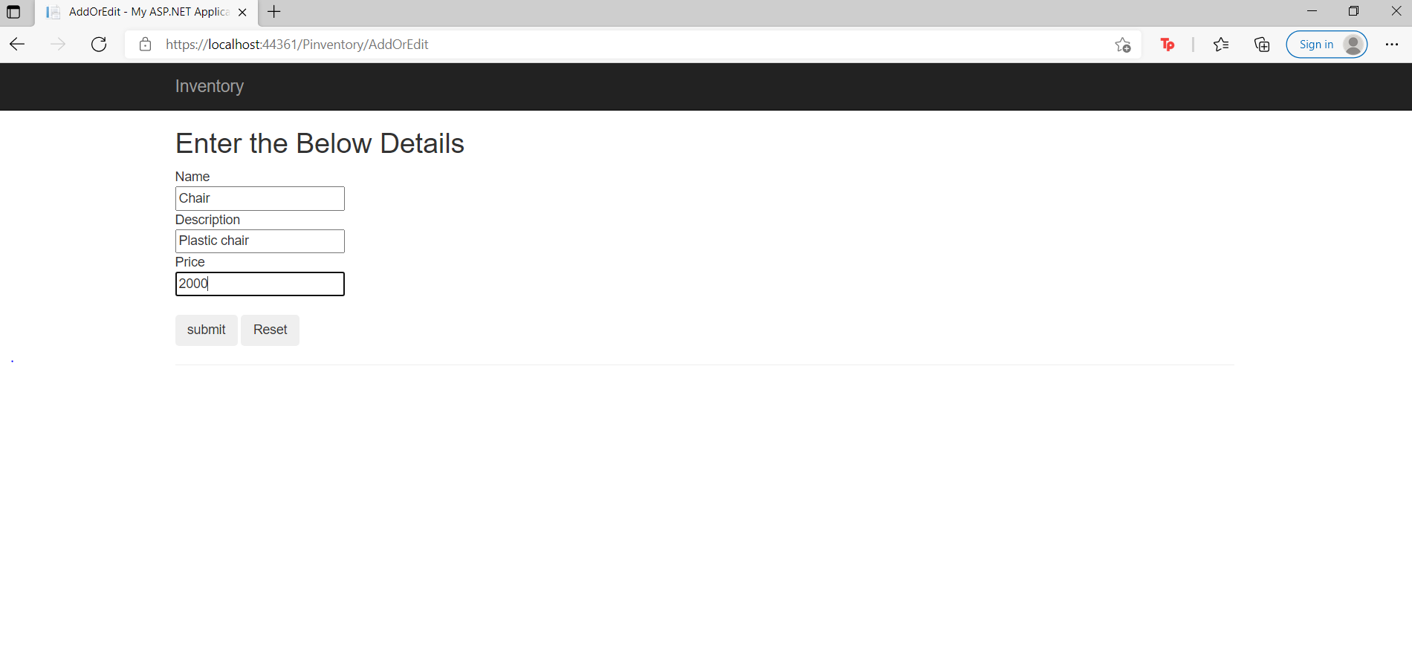

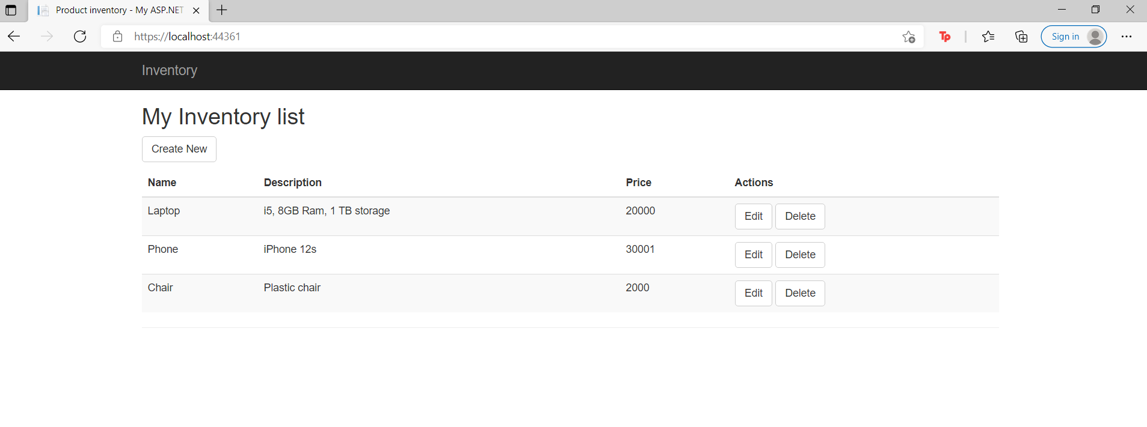

Above screen shots displays the new product added.

1. **Editing the Existing Item**

Now I will edit the price of existing item Chair by clicking Edit button. It will redirect me to ADD/Edit page and fill the old details. Now I will change the price of the chair.

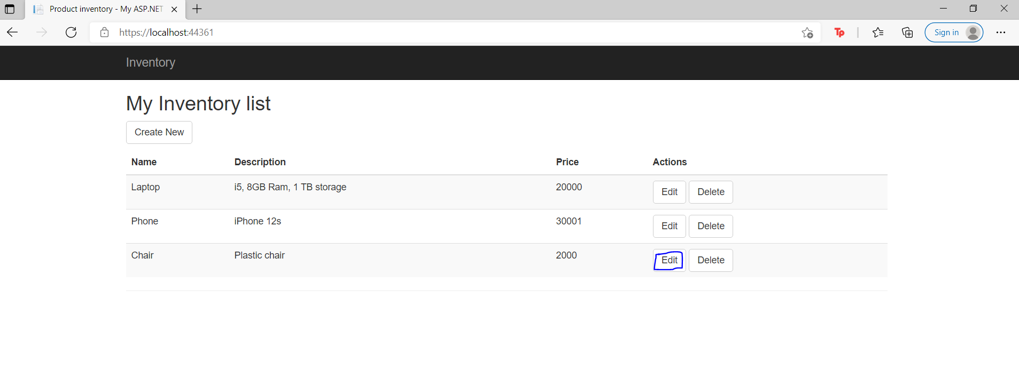

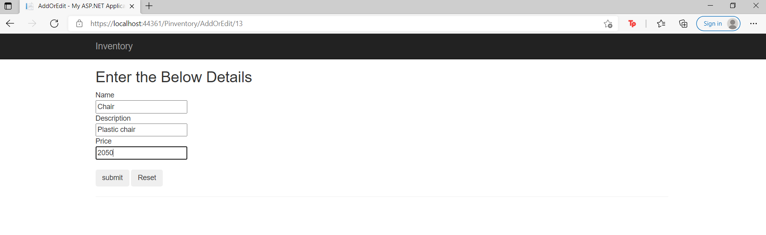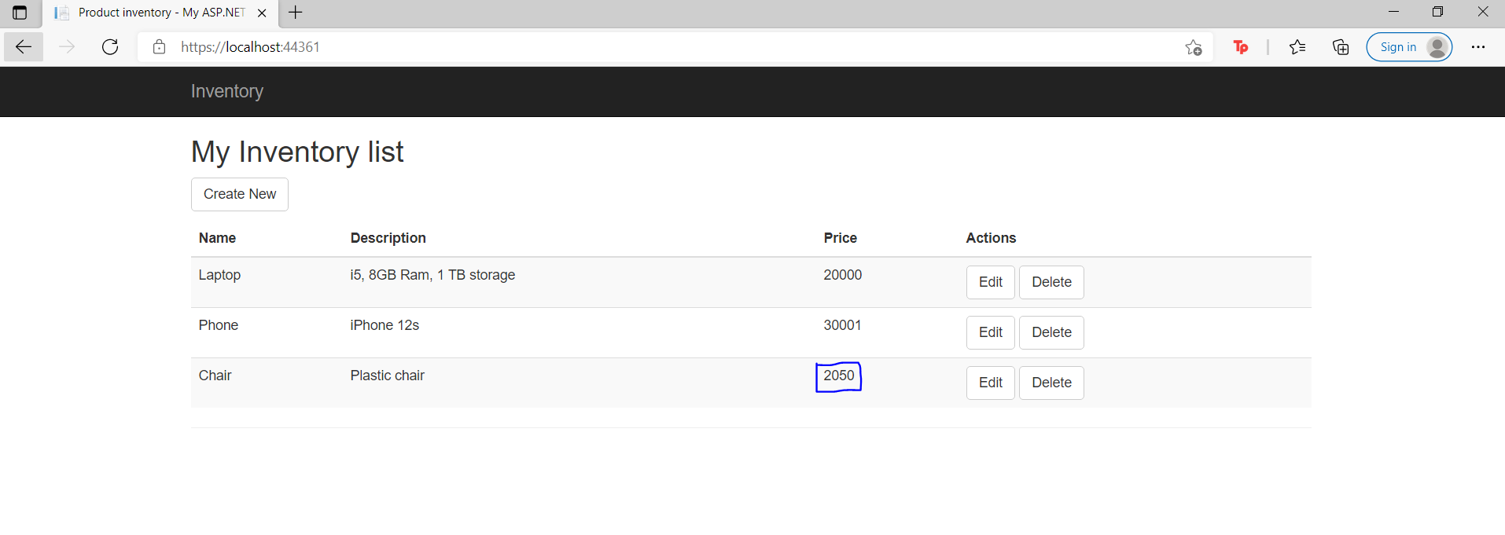

1. Deleting the Item

By clicking on Delete button. The item will be deleted from the home page and also from the database. Now I am deleting the existing item chair from my table using delete button.

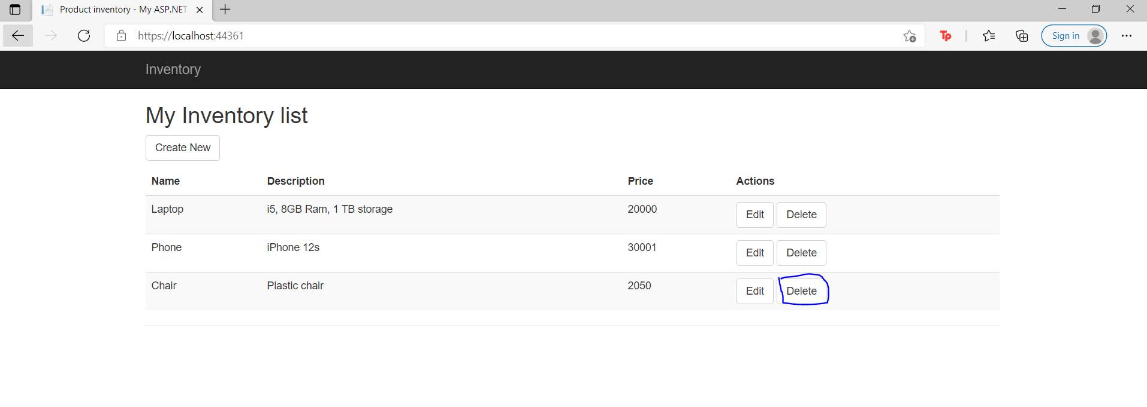

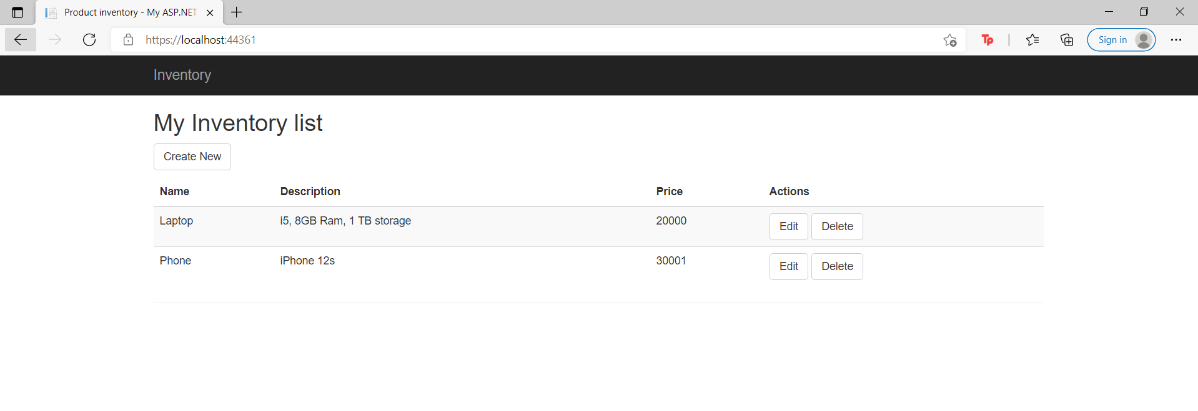

From above the screenshot, you can see the Item chair got deleted.

1. **Required Validation**

If I click on Submit button in my Add/Edit page without filling the Name the alert will be pop up and throws message “This field is required”. This to avoid creating Null values in table.

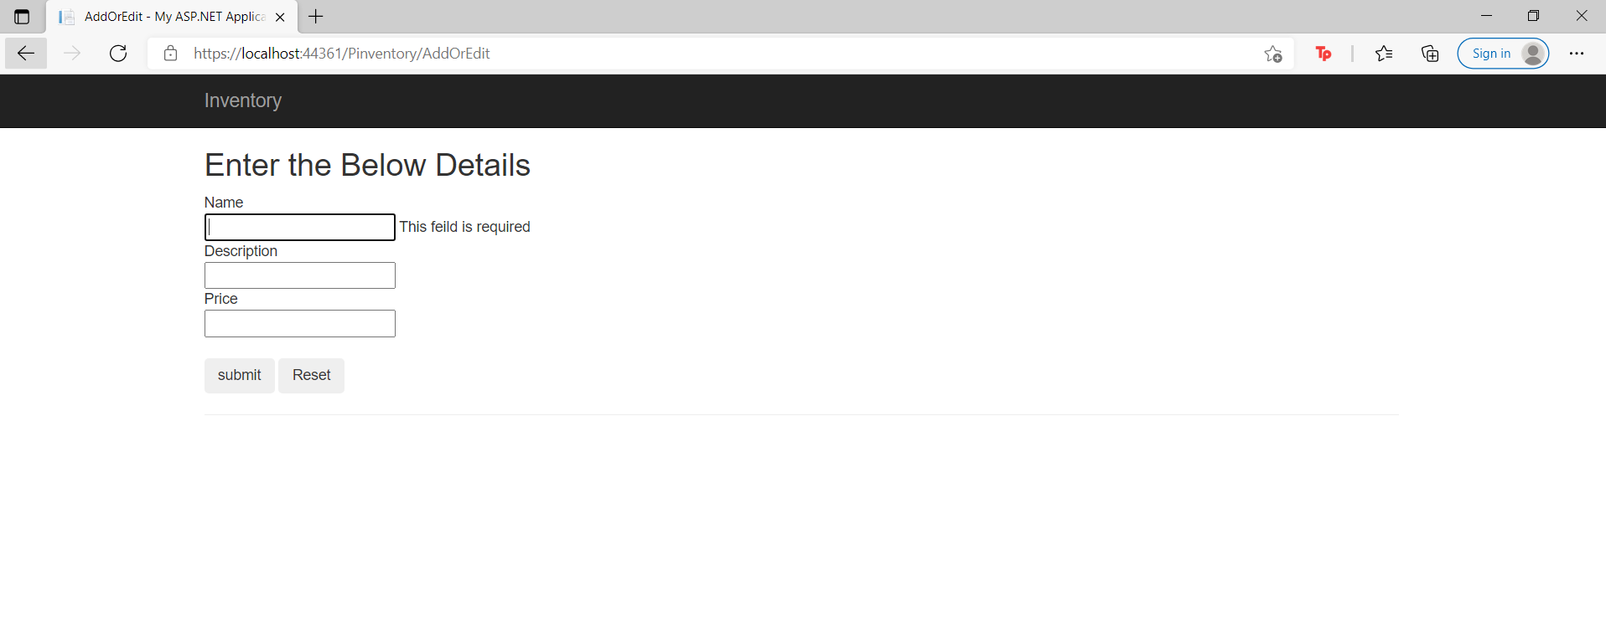

So, above the steps and outcomes of my Shopbridge Application. The code will be added in my GitHub repository. Please find the link below

**Note: If required we can add multiple fields in the form. As of now we created only four fields (Id, Name, Description and Price).**